Wakefield Rural Neighbourhood Policing Team here for you!
Japanese knotweed found in Crofton
Did you know that cannabis isn't the only plant you’re not allowed to grow in your garden?
Japanese knotweed is a non-native plant where under schedule 9, section 14(2) of the Wildlife and Countryside Act 1981 it is an offence if any person plants or otherwise causes to grow in the wild any plant which is included in Part II of Schedule 9 (includes Japanese knotweed).
The plant can grow 1 metre a month and causes a great deal of damage to concrete, cement, tarmac and any brickwork.
It’s not only an offence to grow it, but you also can’t just throw it in the garden waste bin. Disposing of Japanese knotweed is a detailed procedure and needs to be done through the Environment Agency.
This plant was found in a garden in Weeland Road, Crofton on Thursday 20th June.
For more advice please see www.environment-agency

Dog left in hot car in
supermarket car park

A timely reminder........
With the summer nearly upon us and the odd nice day that we are having, please consider your pets.
On the 18th June we had an incident where a dog was locked in a car at a supermarket car park. When the owner returned 45 minutes later the dog was panting heavily, luckily there was nothing more serious this time.
Put this link into your browser (http://ask.rspca.org.uk/rspca/bot.htm?isJSEnabled=1&SiteContext=PUB) and select 'I want to report a dog left in a car on a hot day' and read the information provided…..it might just make some people think twice!!



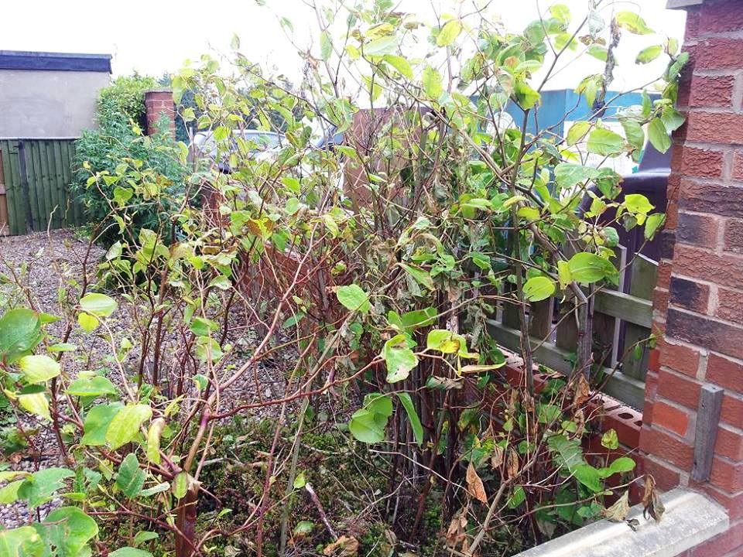

Would you like to join the West Yorkshire Police family by becoming a volunteer?
Do you have 16 hours or more to spare per month to serve your community as a Special Constable?
Keep checking our Facebook page and website for details – we will be recruiting soon!


It’s easy to contact us!
 Call our Non Emergency No ‘101’
 www.westyorkshire.police.uk
 wakefield.rural@westyorkshire.pnn.police.uk

 www.facebook.com/wakefield-rural-npt

 https://twitter.com/wakeyruralnpt

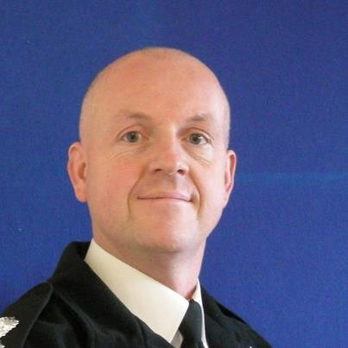

Wakefield Rural NPT
Inspector Richard Clare

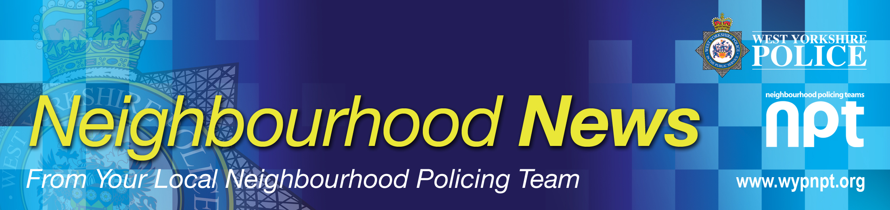
WAKEFIELD RURAL NPT

Wakefield Rural NPT Newsletter - July 2013
Covering Agbrigg, Crigglestone, Crofton, Durkar, Havercroft, Kettlethorpe, Middlestown, Netherton, Newmillerdam, Ryhill, Sandal, Walton, Woolley & surrounding areas.

C
C

Money seized from criminals helps local community

Donation to Agbrigg Road Mosque

Sandal Magna Community Academy held its Fun Day on Saturday 15th June. Pupils, parents and local residents braved intermittent showers to raise funds for Agbrigg Road Mosque.

PCSO Sam McGuire went along with a donation from POCA - Proceeds of Crime. The children got to sit in a police car, and oddly enough always seemed to find the siren switch!

New Football Strip for Durkar Devils

Wakefield Rural NPT have sponsored the Durkar Devils Under 9's football kit for next season.

Sergeant Jonathan Day, PC Laura Robinson and PCSO Alex Bennett from Rural NPT were on hand when the team unveiled the strip on the last day of the current season at a football competition in Newmillerdam on Sunday 16th June.

The new kit has been paid for out of money and assets seized from criminals under the Proceeds of Crime Act (POCA).

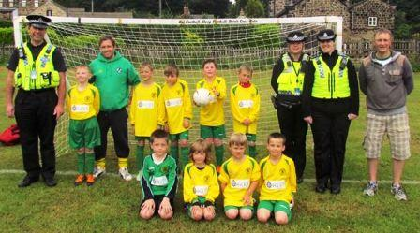
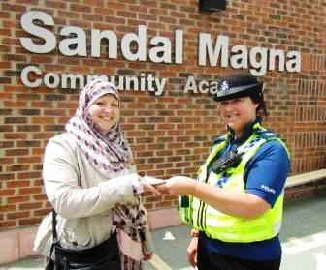
Bikes kept in garden sheds targeted by thieves
5 garden sheds have been broken into in the Calder Grove, Denby Dale and Blacker Lane areas recently, all targeting high-priced bikes. Some were forced but some were insecure.

Here are some guidelines to protect your bike:-
• Buy a shed alarm. They are relatively inexpensive, easy to install and
can be battery or mains powered. Available from most DIY stores or
simply enter ‘Shed alarms’ on the internet.
• Fit strong padlocks and hardware.
• Fit a ground or wall anchor and lock your bike to it.
• Chain bikes/valuables together to stop them being easily removed.
• Security mark your bike with your house number and postcode using a
UV pen, engraving, stamping or paint.
• Keep a record of the serial number, make and model.
• Take a photo of your bike including any accessories.
• Register your bike for free at www.immobilise.com
• Take out insurance – but make sure it covers you for thefts outside the home.

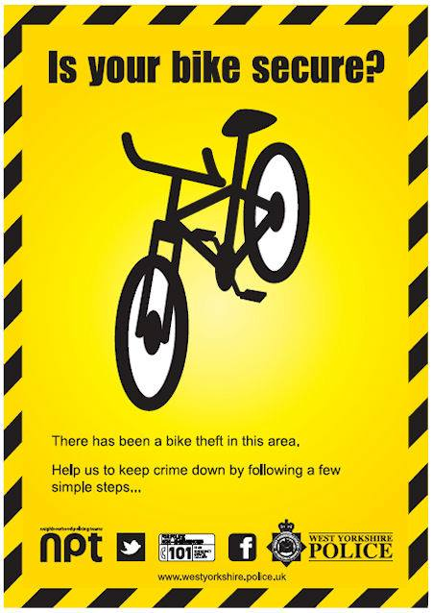


Officer gives talk on Wildlife Crime

PC Ash Wood attended the Wildlife and Countryside Live Event at Ledstone on the 22nd and 23rd May.
He talked about the role West Yorkshire Police play in monitoring and protecting our wildlife against crime and also discussed how to look out for wildlife crime taking place and how people can help us tackle it.
Over the course of the event PC Wood spoke to around 350 pupils from 12 different schools and other community groups. He got some great feedback, with everyone finding the talks interesting and informative.
Visit our website to read more about wildlife crime http://www.westyorkshire.police.uk/about-us/department-profiles/wildlife-crime

Quadbike seized in Havercroft

PC Mills seized the quadbike pictured on Saturday 1st June.
The male driver was riding the quad around Mulberry Place just off Cow Lane. He was driving in an erratic manner and nearly knocked an elderly lady out of her wheelchair.
The driver will be dealt with for driving offences including no insurance, no licence and no MOT.

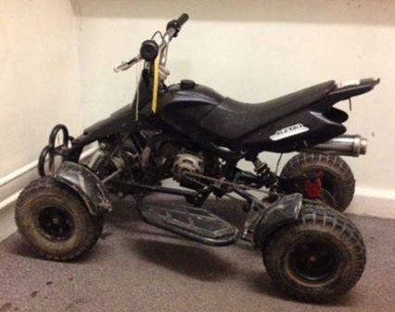
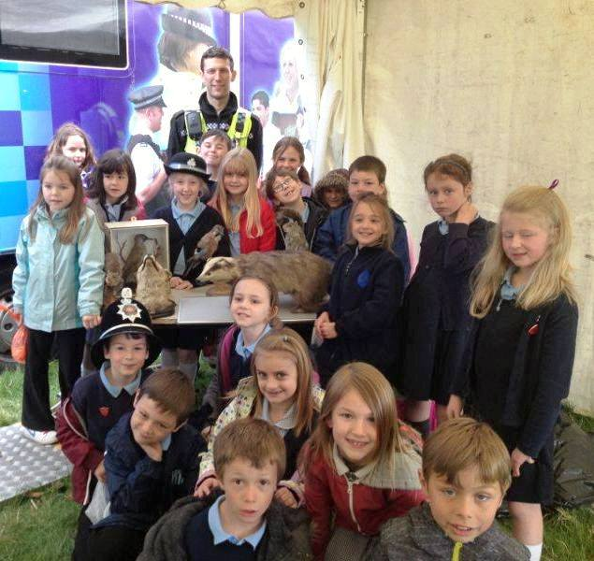

Parking tickets issued in Agbrigg

Following complaints from local residents about parking problems, officers attended the Station Street area of Agbrigg on the morning of Tuesday 25th June. In all 13 tickets were issued for parking offences. Legitimate residents can assist us by displaying their community permits to help highlight motorists that shouldn’t be parked there.

The officers returned on Thursday 27th June and issued 15 more tickets. Incredibly, two of the tickets were issued to the same vehicles!

Speeders targeted on Doncaster Road

Rural NPT officers assisted with speed checks on Doncaster Road in Crofton on the morning of Wednesday 19th June.

Six tickets were issued to vehicles travelling between 47mph and 52mph in a 40mph zone.

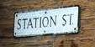

28 tickets issued in 2 days!

Follow us on Twitter:  https://twitter.com/#!/WakeyRuralNPT

Or on our Facebook page:  www.facebook.com/wakefield-rural-npt

Child Sexual Exploitation

Know the Signs
Even something that seems like normal teenage behaviour could be a sign that a child is being sexually exploited.

Some of the visible signs include:

- Regularly missing from home or school and staying out all night
- Change in behaviour – becoming aggressive and disruptive or quiet and withdrawn.
- Unexplained gifts or new possessions such as clothes, jewellery, mobile phones or money that can’t be accounted for.
- Increase in mobile phone use or secretive use
- Appearing to be under the influence of drugs or alcohol
- Being picked up or dropped off in cars by unknown adults
- A significantly older ‘boyfriend’ or ‘friend’ or lots of new friends
- Spending excessive amount of time online and becoming increasingly secretive about time spent online
- Sudden involvement in criminal behaviour or increased offending
- Sexual health problems

If you have any concerns that a child you know may be a victim of Child Sexual Exploitation report it to West Yorkshire Police by calling 101 or you can call Crimestoppers anonymously on 0800 555 111. In an emergency or if a crime is ongoing always dial 999.



Your next local Police and Communites Together (PACT) Meeting

Sandal – Mon 16th July at 7pm – Sandal Rugby Club, Standbridge Lane
Agbrigg – Weds 28th Aug at 6pm – Agbrigg & Belle Vue Community Centre, Montague Street






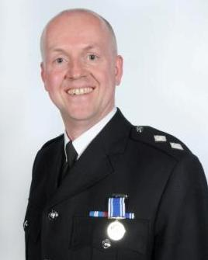
Insp Clare receives his
Long Service and Good Conduct Medal
Congratulations to Rural NPT Inspector Richard Clare who was presented with his Long Service and Good Conduct medal in April.
The medal, which is awarded for 20 years’ service and good conduct, was presented by the Chief Constable Mr Gilmore and the Police and Crime Commissioner Mr Mark Burns-Williamson.

Notton Gala
Sunday 9th June

A budding police officer at Notton Gala!

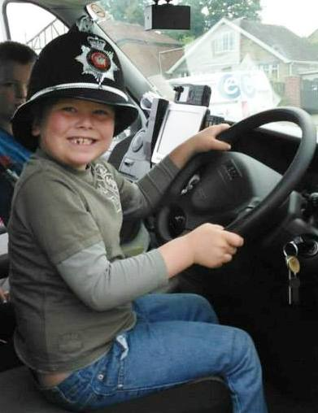
Uninsured vehicle seized in Havercroft
The vehicle pictured was seized on Saturday 8th
June by Sergeant Paul Brooke after the driver
failed to stop on Cow Lane in Havercroft.
The vehicle was found to be uninsured.



